

SOFTWARE REQUIREMENTS
SPECIFICATION (SRS)
For
DEEP LEARNING-POWERED RAILWAY TRACK DETECTION USING RESIDUAL NETWORKS(ResNet)
Version 1.0
Prepared by

S. No | Roll Number | Student Name
1. | 22N31A7314 | G. Thapaswini Reddy
2. | 22N31A7320 | J. Sai Vignesh
3. | 22N31A7326 | K. Purna Harini

Supervisor: | Dr. T. Siva Ratna Sai
Designation: | Associate Professor
Department: | Computational Intelligence
Batch ID: | 22CSMMP1D03
Date:
Supervisor Sign. & Date

Department of Computational Intelligence


Contents Ii
Revisions Iii
1 Introduction 1-4
1.1 Document Purpose 1
1.2 ProJECt Scope 1
1.3 Existing Systems 2
1.4 Problems with Existing Systems 2
1.5 Proposed Systems 3
1.6 Advantages of Proposed Systems 4
2 Overall Description 5-7
2.1 Feasibility Study 5
2.2 Product Functionality 5-6
2.3 Design and Implementation Constraints 6
2.4 Assumptions and Dependencies 6-7
3 Functional Requirements 8-10
3.1 Software Requirement Specifications 8
3.2 Hardware Requirements Specifications 8
3.3 Use Case Model 9-10
4 Other Non-functional Requirements 11
4.1 Performance Requirements 11
4.2 Safety and Security Requirements 11
4.3 Software Quality Attributes 11-12
5 Other Requirements 14
6 REFERENCES 15

Revisions

Version | Primary Author(s) | Description of Version | Date Completed
1.0 | G.Thapaswini Reddy  J. Sai Vignesh  K.Purna Harini | Primary Revision giving an overall view of the project and document. | 17-10-2025

Introduction

Deep learning-powered railway track detection using ResNet applies advanced residual learning to aerial and onboard images to accurately locate rails, sleepers, and fastenings, enabling automated inspection and safety monitoring across diverse environments and improving performance compared to SegNet by handling deeper networks and complex patterns effectively even under varying weather conditions.
Project Goals: Achieve higher accuracy than SegNet, predict track locations and anomalies more precisely, identify defects and obstructions with improved feature extraction, Prioritize maintenance actions efficiently, Support safety and asset management with reliable outputs.
1.1 Document Purpose
The purpose of this document is to define the software requirements for a system designed to detect and analyse railway tracks using deep-learning-powered ResNet-based semantic feature extraction. Accurate railway-track detection is essential for ensuring operational safety, automating inspection processes, and enhancing maintenance planning, where ResNet provides improved accuracy and deeper feature learning compared to the previously used SegNet model. This system aims to support railway infrastructure monitoring and decision-making by providing precise, data-driven insights derived from high-resolution imagery and advanced residual neural-network architectures.
Given the complexities involved in railway environments — such as occlusions, lighting variations, background clutter, diverse track structures, and the need for real-time processing on edge devices — this document outlines the system requirements needed to address these challenges, where ResNet’s skip connections help overcome vanishing gradient issues and enable better generalization than SegNet. The scope includes multiple operational scenarios such as aerial surveillance, onboard cameras, and LiDAR or camera-LiDAR fusion, ensuring the system is robust, scalable, and adaptable to different railway infrastructures and conditions.
This SRS will serve as a comprehensive reference for stakeholders involved in the design, development, implementation, and deployment of the ResNet-based railway-track detection system, offering improved performance, reliability, and scalability over traditional encoder-decoder approaches like SegNet.

1.2 Project/Product Scope
This project aims to build a system that detects and analyses railway tracks using deep-learning–powered ResNet-based feature extraction and segmentation techniques. It will support multiple operational conditions (e.g., high-speed mainlines, freight branches) and diverse infrastructure environments (e.g., open track, tunnel, yard), providing insights for inspection, maintenance planning, and safety monitoring, while achieving higher accuracy and robustness compared to the previously used SegNet model. The system will account for varying track geometries, occlusions, and lighting conditions and will use deep residual networks to deliver more precise and reliable track-area detections through enhanced feature learning.

Key functionalities include:
- Data ingestion from multiple imaging sensors and infrastructure sources.
- ResNet-based detection and segmentation of railway tracks and related assets with improved accuracy over SegNet.
- Classification and mapping of detected track elements using deep residual feature extraction for better representation.
- Visualization of track detection results, defects and change-trends with higher clarity and consistency.
- Customizable ResNet model configurations for different track types and environmental conditions, ensuring scalability and adaptability.

1.3 Existing System
Current railway track detection systems are predominantly manual and labor-intensive. Inspectors often walk the tracks or utilize handheld cameras and sensors to identify issues, which is time-consuming and exposes workers to safety risks, especially in remote or hazardous areas, while earlier deep learning models like SegNet provide limited improvement in accuracy compared to advanced approaches such as ResNet.
Traditional image-based methods, such as edge detection and Hough Line Transform, have been applied to automate parts of the process. However, these techniques struggle with variations in lighting, perspective, and environmental conditions like rain or fog, and SegNet-based models also face limitations in capturing complex features compared to ResNet.
Additionally, these systems face challenges in adapting to diverse terrains, including curved tracks and intersections, and require frequent manual calibration, while SegNet models are less effective in handling deep feature learning due to vanishing gradient issues.
Consequently, existing systems often fail to provide consistent and accurate detection results, underscoring the need for a more robust, intelligent, and automated solution.

1.4 Problems with Existing System
- Limited Feature Extraction: SegNet uses an encoder–decoder architecture that may not capture very deep and complex features, leading to lower accuracy compared to advanced models like ResNet.
- Vanishing Gradient Problem: As network depth increases, SegNet faces difficulty in training effectively due to vanishing gradients, reducing its performance in complex railway environments.
- Lower Accuracy in Complex Conditions: SegNet struggles with variations in lighting, occlusions, shadows, and weather conditions such as rain or fog, resulting in inconsistent detection results.
- Poor Generalization: The model may not adapt well to different track geometries such as curves, intersections, or partially obstructed tracks, affecting reliability across diverse scenarios.
- Higher Information Loss: During the encoding-decoding process, SegNet may lose important spatial details, which impacts precise localization of railway tracks and related components.

1.5 Proposed System
The Railway Track Detection System is our proposed solution to automate the identification of railway tracks using advanced deep learning techniques. This system significantly reduces dependency on manual inspection and accelerates the railway monitoring and maintenance process. By leveraging the ResNet architecture, the system performs enhanced feature extraction and segmentation of track areas from images with higher accuracy compared to SegNet, enabling more reliable and precise detection.
The ResNet model is trained on labeled datasets of railway track images to learn complex patterns, textures, and spatial relationships using deep residual learning, which improves performance over SegNet by avoiding vanishing gradient issues. During operation, the system classifies each pixel in an input image as either track or non-track with improved precision, ensuring robust performance even in challenging environments such as curves, intersections, shadows, or occlusions caused by objects like debris or vegetation.
In addition to accuracy, the system ensures faster and more efficient processing, making it suitable for large-scale deployment in railway surveillance and inspection tasks compared to SegNet-based approaches. It can also be integrated with drone or camera-based monitoring systems for real-time detection and reporting.
By providing timely and precise information, the proposed system supports proactive maintenance planning, early fault detection, and accident prevention, thereby improving the overall safety, efficiency, and reliability of railway infrastructure. Furthermore, this intelligent solution highlights the advantages of ResNet over SegNet in delivering better accuracy, scalability, and performance in modern railway inspection systems.

1.6 Advantages of Proposed system
- Real-Time Processing: Optimized with ResNet architecture, the system enables fast and efficient track detection by utilizing deep residual learning, supporting real-time identification of anomalies during train operations.
- Robustness Across Conditions: ResNet provides strong performance across diverse terrains and environmental conditions by capturing deep and complex features, ensuring reliable detection under varying lighting and weather scenarios.
- Improved Accuracy: The use of residual connections allows ResNet to learn richer feature representations, resulting in higher precision in detecting railway tracks and related components.
- Scalability: The deep architecture of ResNet supports scalability, making it suitable for large railway networks and adaptable to different datasets and environments.
- Efficient Feature Learning: ResNet minimizes information loss and overcomes vanishing gradient issues, enabling better training of deeper networks and more accurate detection results.

Overall Description

Feasibility Study

1. Objective
To assess the feasibility of developing and deploying a deep learning-powered railway track detection system using ResNet-based feature extraction and segmentation techniques, optimized for real-time edge processing and integrated into existing railway infrastructure monitoring systems.
2. Technical Feasibility
Requirements:
- Data: High-resolution images of railway tracks, including diverse and well-labeled datasets.
- Modelling tools Python with libraries such as TensorFlow, PyTorch, and OpenCV.
- Edge Processing: Efficient ResNet-based models optimized for real-time inference.
- Deployment: Edge devices with GPU support.
Feasibility:
- Deep learning models, particularly ResNet, have demonstrated high accuracy in image classification and segmentation tasks by enabling deeper network training with residual learning.
- Suitable for small to large-scale datasets with better generalization capability.
- ResNet-based models can be optimized to process data efficiently, enabling near real-time detection and response.
3. Operational Feasibility
Resources Needed:
- Data analyst or data scientist for model development.
- Developer for dashboard and deployment.
- Minimal IT support post-deployment.

Integration:
- The system can be integrated with existing railway monitoring platforms, providing real-time alerts and facilitating proactive maintenance.
- User-friendly interfaces can be developed for operators to monitor system performance and receive notifications.
Feasibility:
- Operational deployment is feasible with a skilled team and existing infrastructure.
- The system's real-time capabilities enhance operational efficiency and safety.
4. Economic Feasibility
Estimated Costs:
- Development Time: 2–4 weeks (internal or outsourced).
- Tools: Open-source (free).
- Hosting: Free or low-cost.
Expected Benefits:
- Reduced downtime and maintenance costs through accurate and early detection of tracks.
- Enhanced safety by identifying potential hazards before they lead to incidents.
- Improved resource allocation by automating routine inspection tasks.
Feasibility:
- The return on investment is high, with potential cost savings
- The system is cost-effective, particularly for large-scale railway networks.
5. Legal & Data Privacy Feasibility
Considerations:
- Secure rights for any proprietary models or datasets used.
- Ensure proper data anonymization and encryption.
- Use secure, access-controlled hosting.
Feasibility:
- Legally viable with basic data protection measures.
- Can be implemented responsibly with minimal legal risk.
Conclusion: Developing and deploying a deep learning-powered railway track detection system using ResNet is technically, operationally, economically, and legally feasible. The use of residual learning with efficient processing capabilities provides a robust and scalable solution for modern railway infrastructure monitoring, leading to improved safety, accuracy, and overall system efficiency.

Product Functionality
- Railway Track Detection: Utilizes ResNet-based deep learning models to accurately extract and identify railway tracks from high-resolution images or LiDAR point clouds through enhanced feature representation.
- Anomaly Detection: Detects and classifies potential track anomalies, including misalignments, obstructions, and surface defects, by leveraging deep residual features learned from track regions.
- Data Input: Accepts various data formats, including high-resolution images and LiDAR point clouds, enabling flexible input handling for multiple sensor sources.
- Real-Time Processing: Optimized ResNet models can be adapted for edge devices like NVIDIA Jetson or Google Coral, enabling efficient inference and timely anomaly detection without heavy reliance on cloud systems.
- Deployment: Designed for seamless integration into existing railway monitoring systems, providing automated and reliable track inspection using advanced residual learning techniques.

Design and Implementation Constraints
1. Technical Constraints
- Programming Language: The backend logic must be implemented using Python 3.x.
- Deep Learning Framework: The ResNet-based models must be developed using TensorFlow or PyTorch.
- Model Optimization: Models should be optimized using techniques such as pruning and quantization to improve efficiency while maintaining the depth advantages of ResNet.
- Data Input Formats: The system should accept high-resolution images and LiDAR point clouds as input.
2. Functional and Operational Constraints
- Real-Time Processing: The system must process data in real-time, with models achieving inference rates suitable for edge deployment.
- Environmental Variability: The system must handle varying environmental conditions, including different terrains and weather scenarios, using robust feature extraction capabilities of ResNet.
- Model Size and Complexity: ResNet models must be balanced in depth and size to meet memory and processing constraints of edge devices.
3. Hardware Constraints
- Processor Requirement: The edge device must have a minimum of an Intel i5 processor or equivalent for smooth local execution.
- Memory Requirement: The device must have at least 8 GB of RAM to efficiently handle deep learning inference tasks.
- Storage Requirement: A minimum of 256 GB HDD/SSD is needed to store models, dependencies, and temporary data.
- GPU Support: The device should include a GPU to accelerate deep learning computations, such as the NVIDIA Jetson's integrated GPU.
These constraints ensure that the system is optimized for real-time railway track detection and can operate efficiently within the limitations of edge computing environments.

2.4 Assumptions and Dependencies

The following assumptions and dependencies are critical to the successful development and implementation of "Deep Learning-Powered Railway Track Detection Using ResNet".
Assumptions
- Data Availability: It is assumed that high-resolution images or LiDAR point clouds of railway tracks are accessible for processing. The system's performance depends on the quality and resolution of the input data used for training ResNet models.
- Edge Device Compatibility: The system assumes deployment on edge devices such as Google Coral or NVIDIA Jetson, which provide sufficient computational capability for efficient ResNet inference.
- Model Accuracy: It is assumed that the ResNet-based models are trained effectively to achieve high accuracy in detecting and extracting railway track features under various environmental conditions.
- User Expertise: The system assumes that users, such as railway maintenance personnel, have the required technical knowledge to operate the system and interpret the outputs correctly.
Dependencies
- Deep Learning Frameworks: The system depends on frameworks like TensorFlow or PyTorch for implementing and deploying ResNet models.
- Edge Computing Hardware: Deployment relies on edge computing hardware, specifically devices like Google Coral, to facilitate real-time processing.
- Input Data Sources: The system's functionality is dependent on the availability of high-resolution images or LiDAR point clouds of railway tracks, which serve as the primary input data.
- Model Optimization Tools: Techniques such as pruning and quantization are required to optimize ResNet models for efficient execution on edge devices with limited resources.
Conclusion
The deep learning-powered railway track detection system using ResNet leverages advanced residual learning techniques to improve the accuracy and efficiency of railway infrastructure monitoring. By deploying optimized ResNet models on edge devices, the system enables reliable detection and analysis of track conditions, supporting proactive maintenance and enhanced safety. The project is technically feasible, utilizing robust tools and hardware, and provides an effective solution to the limitations of traditional inspection methods.

Functional Requirements

Software Requirement Specifications
- Programming Language: Python 3.8
Libraries:
- Data: TensorFlow, OpenCV
- IDE: Jupyter Notebok, VS Code
- Visualization: Seaborn, Matplotlib, Plotly
- Web App: Streamlit
- Version Control System: Git/Github

Hardware Requirements Specifications

- CPU: 2.0 GHz Dual Core
- RAM: 8 GB
- Storage: 2 GB

Use Case Model
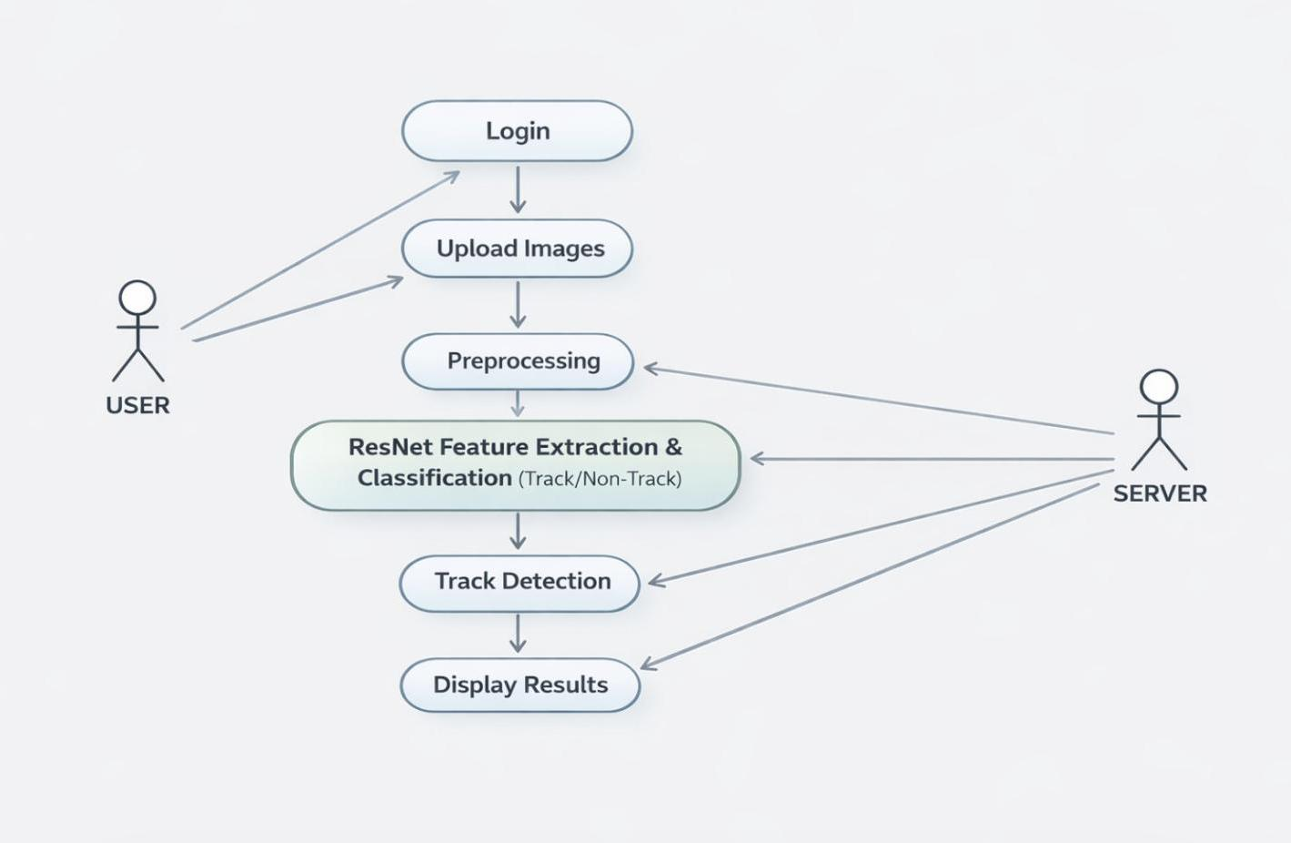

Use Case #1 (Game Play – U1)

Actors:
- User: Uploads data, views Track predictions, and downloads reports.
- System (ResNet Track Detection System): Processes input data, performs ResNet-based feature extraction and classification to identify railway tracks, detects anomalies, and provides real-time feedback.
Use Cases:
- Upload Track Data (Images)
- Preprocess Input Data
- Run ResNet Model
- Detects track or non-track
- Generate Real-Time Reports
- Display results

Data Flow Diagram

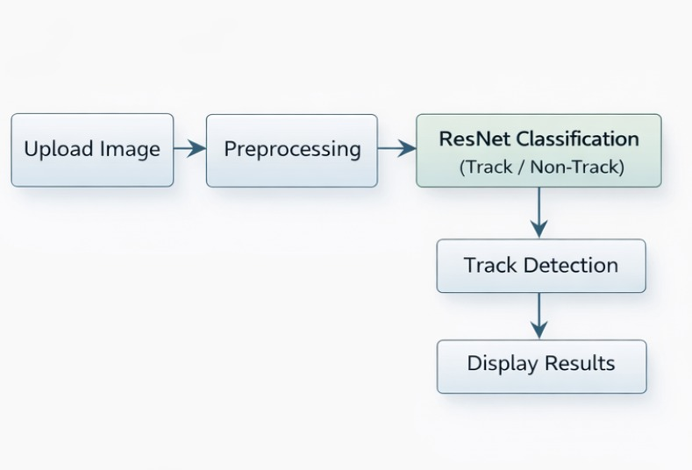

Other Non-functional Requirements

4.1 Performance Requirements
- Response Time: The system shall process and return railway track detection results for input images or LiDAR point clouds within 200 milliseconds.
- Throughput: The system should support processing of at least 30 frames per second (FPS) on edge devices such as NVIDIA Jetson or Google Coral, ensuring real-time performance.
- Scalability: The system must handle increasing data volumes gracefully, with options to scale resources as needed to accommodate higher input resolutions or more complex scenarios.
- Accuracy: Detection accuracy should achieve a higher mean Intersection over Union (mIoU) compared to SegNet, ensuring improved precision in railway track detection tasks
- Availability: The system shall maintain 99% uptime during operational hours to ensure continuous accessibility.
- Data Handling: The system should validate input data efficiently, ensuring only clean and correctly formatted inputs are processed by the ResNet model.

4.2 Safety and Security Requirements
- Data Privacy: Ensure all input data is handled in compliance with data protection laws such as GDPR and CCPA. Data must be anonymized or encrypted where necessary.
- Secure Data Transmission: Use HTTPS protocols to protect data during upload and download between the user and the system.
- Access Control: Implement user authentication and role-based access to restrict unauthorized access to the system and data.
- Data Storage: Avoid persistent storage of sensitive data unless explicitly authorized by the user. Any stored data must be encrypted.
- Error Handling and Logging: Log system activities securely while avoiding logging sensitive data. Ensure error messages do not expose sensitive information.
- System Integrity: Protect the system from common security threats such as SQL injection, cross-site scripting (XSS), and denial-of-service (DoS) attacks through best security practices.
- Backup and Recovery: Maintain regular backups and disaster recovery procedures to prevent data loss and ensure system availability.

4.3 Software Quality Attributes
- Usability: The system should be intuitive and easy to use for railway maintenance personnel with minimal technical expertise.
- Reliability: The system must provide consistent and accurate track detection results, maintaining high availability (99% uptime).
- Performance: The system should deliver fast response times (under 200 milliseconds) through optimized ResNet processing.
- Scalability: The system must handle increasing data volumes and concurrent users efficiently using scalable ResNet architectures.
- Security: Data privacy and protection must be ensured through encryption, secure transmission, and controlled access throughout the ResNet-based processing pipeline
- Maintainability: The codebase should be modular and well-documented to support easy updates, debugging, and improvements in ResNet model configurations.
- Portability: The system should be deployable on various edge computing platforms with minimal configuration changes, ensuring compatibility of ResNet models across devices.
- Accuracy: The ResNet-based track detection models should produce results with a mean Intersection over Union (mIoU) of at least 83.3%, delivering improved precision and reliability.
These requirements ensure that the railway track detection system is efficient, secure, and user-friendly, meeting the operational needs of railway maintenance personnel.

Other Requirements

- Documentation
  - User Manual: A comprehensive guide will be provided to assist railway maintenance personnel in uploading data, interpreting detection results, and exporting reports.
  - Technical documentation: Detailed documentation will include system architecture, data flow, semantic segmentation model and deployment instructions for developers and system maintainers.
- Training
  - Training Materials: Basic training materials, such as video tutorials or PDF guides, will be available to users for self-paced learning.
  - User Interface: The system's intuitive design minimizes the need for formal training, assuming users are familiar with standard web interfaces and file uploads.
  - In-App Assistance: The system will include in-app tooltips or help text to assist first-time users.
- Compliance
  - Data Privacy: The system will comply with relevant data privacy regulations, including GDPR (EU) and CCPA (California). All input data will be anonymized or pseudonymized before processing.
  - Data Storage: No personal or sensitive data will be stored permanently unless explicitly permitted. Encrypted storage solutions will be employed where necessary.
  - Secure Transmission: The system will use HTTPS to encrypt all data transmissions between client and server, ensuring secure communication.
- Backup & Recovery
  - Automated Backups: The system will implement automated backups for configuration files and processed data (if stored), ensuring data integrity.
  - Disaster Recovery Plan: A comprehensive disaster recovery plan will be in place to restore functionality in case of data loss, corruption, or platform failure.

- Support & Integration
  - User Support: Users will have access to basic support, such as a helpdesk email or ticketing system, for reporting issues or requesting assistance.
  - Maintenance Procedures: Maintenance tasks (e.g., model updates, system optimizations) will follow a structured version control and release process to ensure system stability.
  - System Integration: The system will be designed to integrate with other tools (e.g., asset management systems, maintenance scheduling platforms) through APIs or exportable formats, facilitating future scalability and interoperability.
This comprehensive approach ensures that the railway track detection system using ResNet is user-friendly, compliant with data privacy regulations, and equipped with robust support and integration capabilities.

References

- Khrueakhrai, S., & Srinonchat, W. (2025). Railway Track Detection Based on ResNet Deep Learning. ResearchGate.
- Chen, Z. (2024). RailSegVITNet: A Lightweight ViT-Based Real-Time Track Detection Model. ScienceDirect
- Tang (2024). A Real-Time Method for Railway Track Detection and 3D Fitting Based on Camera and LiDAR Fusion Sensing. Remote Sensing, 16(8), 1441
- Vision-Based Railway Track Monitoring Using Deep Learning Link: arXiv
- A Real-Time Method for Railway Track Detection and 3D Fitting Based on Camera and LiDAR Fusion Sensing Link: MDPI Remote Sensing
- Mittal, S. (2017). Vision-Based Railway Track Monitoring Using Deep Learning.

SRS DOCUMENT REVIEW

CERTIFICATION

This Software Requirement Specification (SRS) Document is reviewed and certified to proceed for the project development by the Departmental Review Committee (DRC).
Date of SRS Submitted:

Date of Review:
Supervisor Comments:
Supervisor Sign. & Date.
Coordinator Sign. & Date
HOD Sign. & Date
Dept. Stamp

